
Company
Logotype

Cone Beam Computed Tomography- Report



Porur Dental X-rays & CBCT

Patient Name : Mrs. Malliga | Date of Report : 28.02.2024
Age/ Gender : 70 years/ Female | Region of Interest : CBCT Maxilla
Referring doctor: Dr. Boominathan | Indication : Implant assessment
Clinical Notes: Nil
PATIENT INFORMATION

CBCT- Maxilla provided
CBCT – IMAGE DETAILS

RADIOGRAPHIC INTERPRETATION

- Completely missing crown and root in relation
- Root stumps: 23, 24, 28.
- Crown in relation to: 11, 12, 13, 14, 15, 16, 17, 21, 22.
- Presence of hyperdense structures suggestive of surgical wires evident in the anterior maxillary region.
- Presence of discontinuity in relation to the floor of the left maxillary sinus in relation to 24, 25 region causing oro- antral communication.

IMPLANT ASSESSMENT

 | 11 region | 12 region | 13 region | 14 region | 21 region | 22 region | 23 region | 24 region
Sub-Crestal | 6.64 | 7.07 | 6.76 | 9.34 | 6.15 | 4.13 | 7.32 | 7.82
Mid- Crestal | 7.12 | 6.91 | 7.08 | 9.29 | 6.48 | 5.04 | 8.38 | 8.93
Distance between the alveolar ridge and Floor of the Nasal cavity (in mm) | 22.55 | 20.23 | 16.46 | 16.99 | 19.15 | 20.4 | 16.99 | 18.56

 | 15 region | 16 region | 17 region | 25 region | 26 region | 27 region
Sub-Crestal (in mm) | 3.01 | 2.93 | 12.1 | 6.46 | 3.84 | 4.8
Mid- Crestal (in mm) | 3.92 | 3.98 | 12.97 | 6.34 | 4.82 | 5.87
Distance between the alveolar ridge and floor of the maxillary sinus (in mm) | 15.38 | 10.19 | 11.31 | 22.99 | 14.72 | 7.75

RADIOGRAPHIC IMPRESSION

- Partially edentulous maxillary arch.
- Generalized Chronic Periodontitis.
- Root stumps.
- Oro-antral communication- Left side.

Kindly correlate with clinical findings


IMAGES FOR REFERENCE

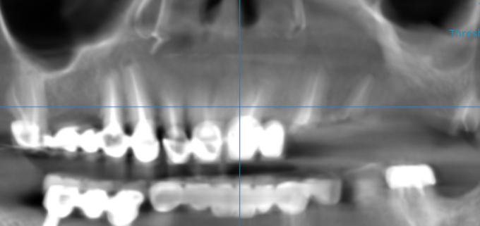

3-DIMENSIONAL VIEW

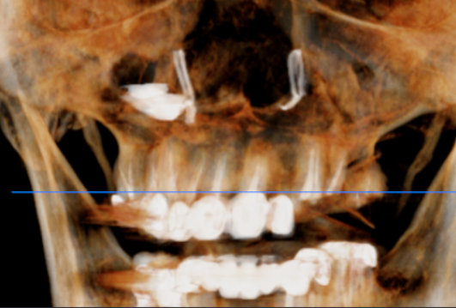

CROSS SECTIONAL VIEW

11 region | 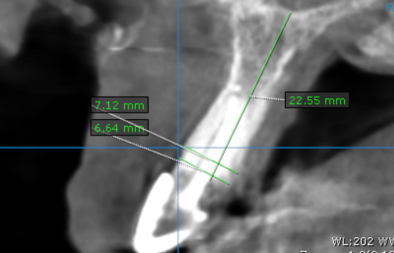
12 region | 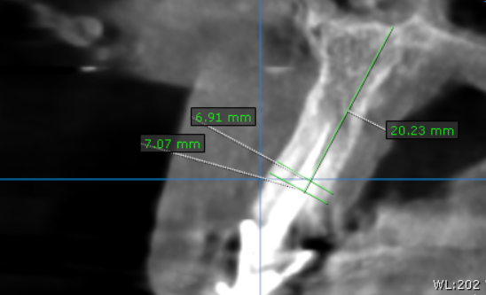
13 region | 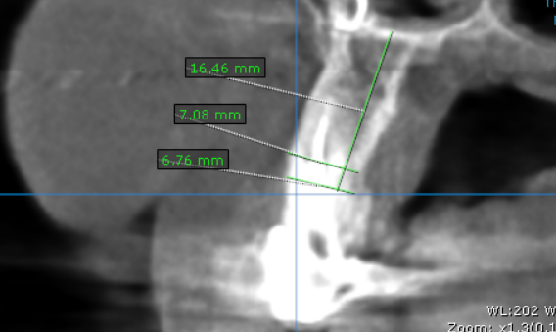
14 region | 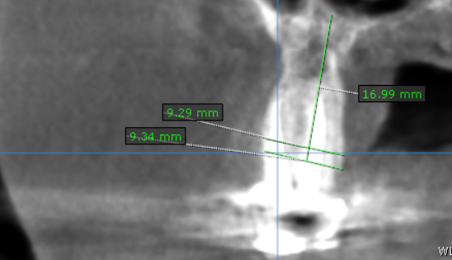
15 region | 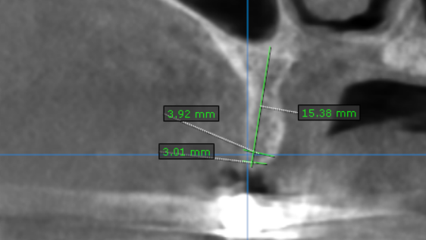
16 region | 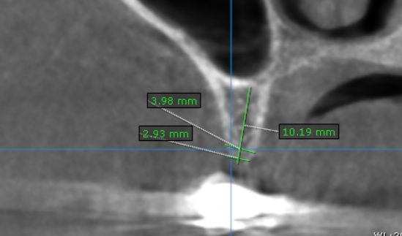
17 region | 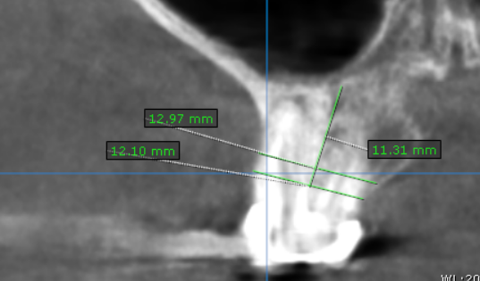
21 region | 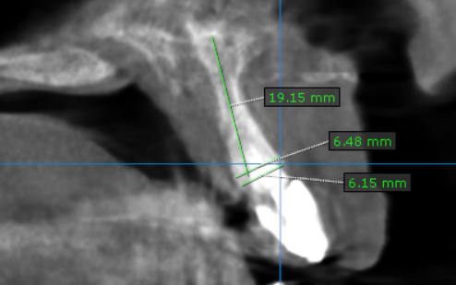
22 region | 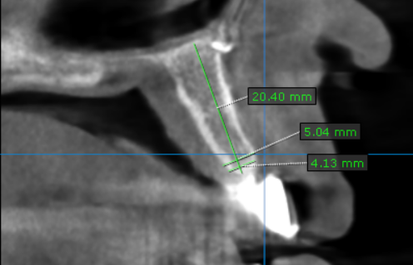
23 region | 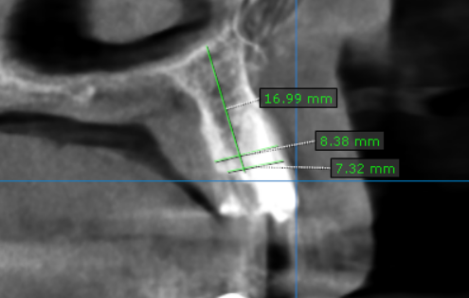
24 region | 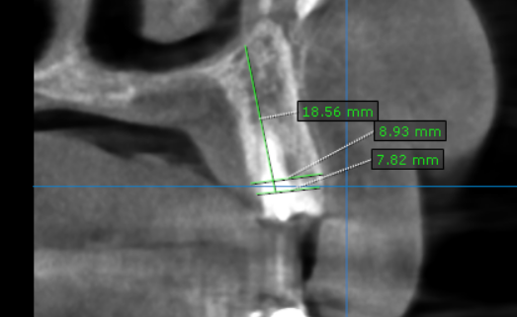
25 region | 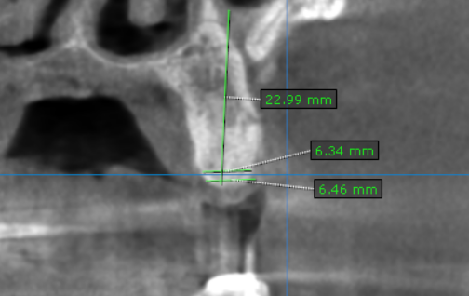
26 region | 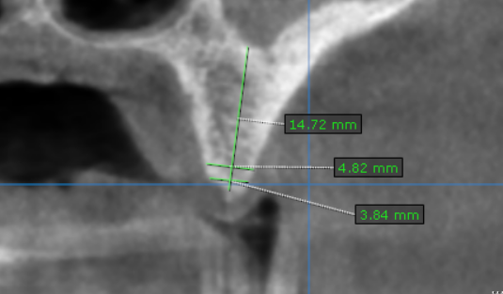
27 region | 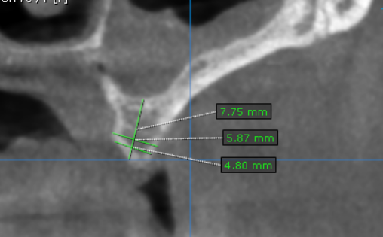

**** End of report ****

